***Submit **ROUTINE** work order requests to our org box by filling out this form and emailing it to [718ces.servicecall@us.af.mil](mailto:718ces.servicecall@us.af.mil). Please include house number/unit letter or apt number, a good contact cell number (**no stateside numbers please**), name of sponsor and housing service needed. **NOTE**: If you click Submit button below the link to our org email is automatically populated in email.

Date

Last Name First Name

Facility Number Housing Area

Phone Number Email Address

Area of Need Electric Plumbing

Air Conditioning

Heater

Structure

Locksmith

How can we help you?

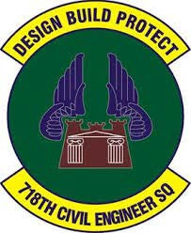

*718 CES/Housing Maintenance Customer Service*

[**Submit**](mailto:718ces.servicecall@us.af.mil)